**RAD Model**

Rapid Application and Development (RAD) Model makes heavy use of reusable software components with an extremely short development cycle

**Various phase or Steps of RAD Model**

* + Business modeling
  + Data modeling
  + Process modeling
  + Application generation
  + Testing and turnover

Advantage of RAD Model

* This model is flexible for change.
* In this model, changes are adoptable.
* Each phase in RAD brings highest priority functionality to the customer.
* It reduced development time.
* It increases the reusability of features.

Disadvantage of RAD Model

* It required highly skilled designers.
* All application is not compatible with RAD.
* For smaller projects, we cannot use the RAD model.
* On the high technical risk, it's not suitable.
* Required user involvement
* Challenges/drawbacks:
  + For large projects, sufficient human resources are needed for rapid cycle
  + Strong commitment from developers and customers
  + Not all types of applications are appropriate for RAD. If a system cannot be properly modularized --
  + RAD is not appropriate when technical risks are high.
  + Reusability sometimes implies loss of performance

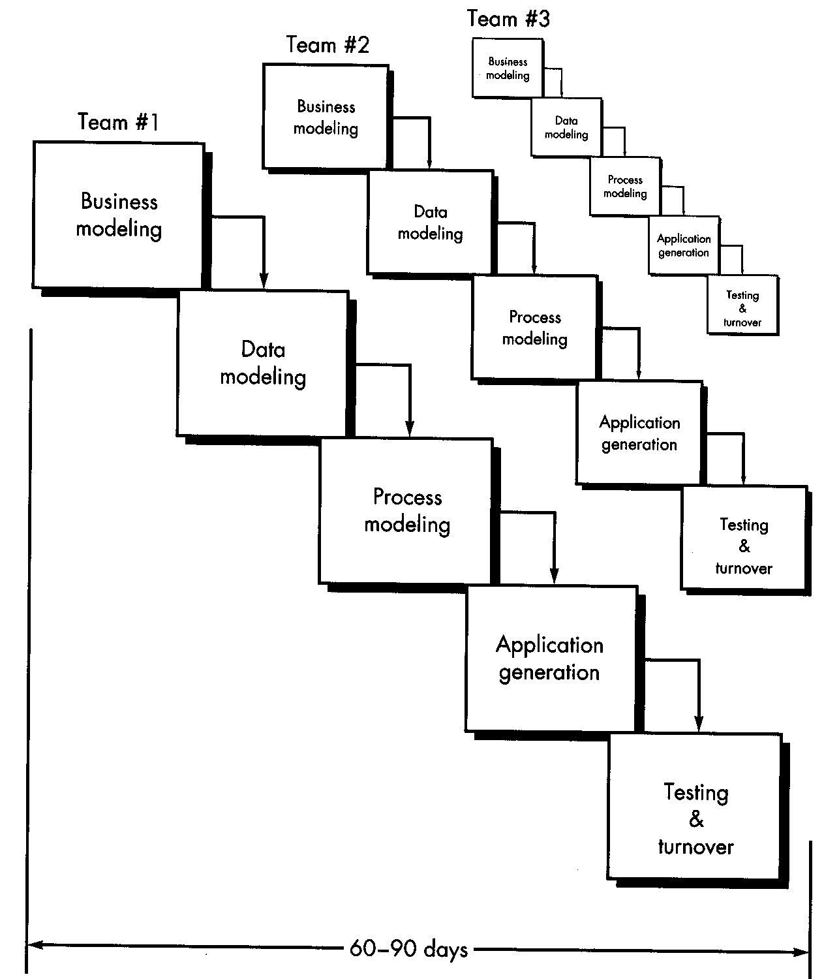

When to use RAD Model?

* When the system should need to create the project that modularizes in a short span time (2-3 months).
* When the requirements are well-known.
* When the technical risk is limited.
* When there's a necessity to make a system, which modularized in 2-3 months of period.
* It should be used only if the budget allows the use of automatic code generating tools.

**Incremental Model**

Incremental Model is a process of software development where requirements divided into multiple standalone modules of the software development cycle.

**spiral model**

The **spiral model** is similar to the incremental **development** for a system, with more emphasis placed on risk analysis

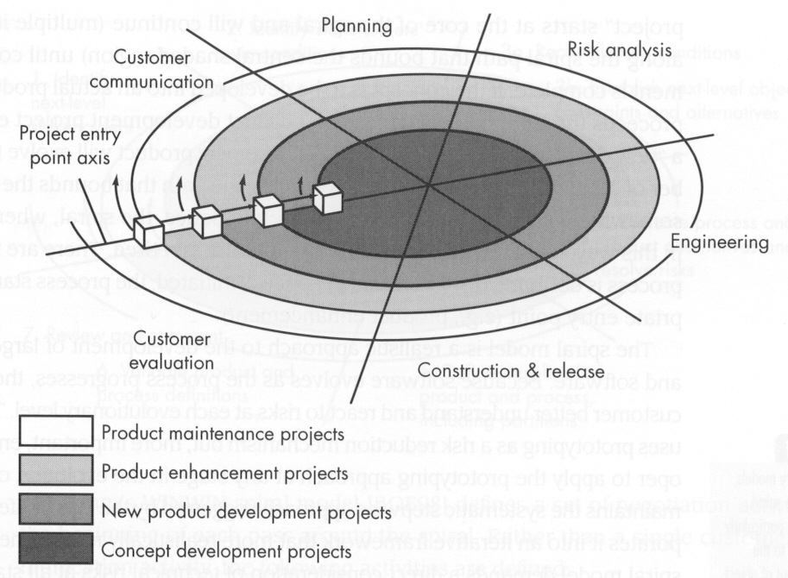

Challenges:

* + Hard to show controllability  
    (size and timing of each circuit)
  + Risk assessment is fundamental
  + Model fairly new (less experience)

**Win-Win Spiral Model**

The WinWin spiral model, which extends the spiral software development model by adding Theory W activities to

the front of each cycle. WinWin, a groupware tool that makes it easier for distributed stakeholders to negotiate mutually satisfactory (win-win) system specifications.

